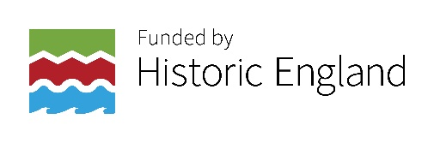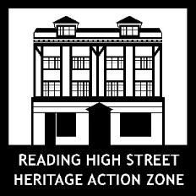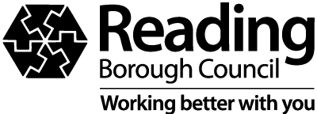

Oxford Road Community Call Out
Are you a community group or organisation based in the Oxford Road area?
Would you like to be involved in a cultural project to celebrate the history and diverse cultures of the Oxford Road?

Do you want to be involved in creating cultural activities that are meaningful and relevant to your members/participants/the people you work with/the people you support/ the local community?

Do you have an idea for a creative project to explore and share local history and celebrate the cultural identity of the communities along the Oxford Road and is there a local artist that you would like to work with on this? Or maybe you have an idea but and you would like support to find an artist or creative practitioner to work with you on your idea?

Is there an area/issue that is important to your group that you would like to address like isolated older people, giving young people the chance to contribute to their community, connecting people across the generations that a cultural project could help you start to address?

Do you offer a service to the Oxford Road community and would you like to enhance this offer by providing the opportunity to take part in creative activities alongside your service?

Or maybe the above questions have sparked an interest, but you have no idea where to start and you would like to find out more?

The project
Reading Borough Council is looking to work with groups, organisations and communities from the Oxford Road area to discover creative opportunities and develop new projects with local people that celebrates the history and diverse cultures of the area.

Reading High Street Heritage Action Zone Cultural Programme supports communities to co-create new work with artists and creative practitioners that is relevant, authentic and genuinely participatory for people living in the 3 action zone areas which Oxford Road is one.
High Street Heritage Action Zones (HSHAZ) is a government-sponsored programme to transform high streets through the power of heritage. HSHAZ scheme seeks to deliver physical improvements and cultural and community activities to regenerate historic high streets or town centers. Reading has identified the retail part of three conservation areas; Castle Hill/Russell Street/Oxford Road, St Mary’s Butts/Castle Street, and Market Place/London Street. The aim is to make these high streets more attractive, engaging and vibrant - as places for people to live, work and spend time. More information of the HSHAZ Programme can be found at: www.reading.gov.uk/hshaz
What is important to us is that local communities are involved in the design and delivery of the HSHAZ Cultural Programme projects, and that the programme reaches people who not normally have this kind of creative opportunity.
Your project needs to offer local community members the opportunity to take part in creative and cultural activities together that:
- are inspired by the history of the area and celebrates the diverse cultures of the Oxford Road
- are co-created with them involving them in the design and delivery of the activities
- enables them to work with an artist or creative practitioner to co-create work that is meaningful and relevant to them and the local community.
Our definition of creative and cultural activities is broad it can be music, photography, singing, drama, spoken word, creative writing, dance and movement, painting, craft, ceramics, sculpture, film or a mixture of two creative and cultural activities.

How can Reading High Street Heritage Action Zone support you:
- We can provide a small grant of up to £4,000 to set up and run your creative project idea with the members of your group and/or your local community
- We can offer support to help community groups and organisations to develop their skills and confidence in developing creative and cultural activities including developing your project idea and getting you project up and running. This support will be provided by Culture Mix Arts a respected Reading based cultural organisation.
- If applicable, we can link you with an artist or creative practitioner to work with on your project
- We can link you with other community groups or organisations that are working on the programme or who are developing creative and cultural opportunities for communities in Reading.

Application Process
Stage 1 – Expression of Interest

We have tried to make the process as accessible as possible, so there are two ways to apply at this stage: by completing the Expression of Interest Form below in writing or by sending us a short video or audio recording of your answers to the questions on the form (no longer than 4 mins).

Please send you completed form or video or audio recording to HSHAZ@reading.gov.uk by 5pm on Monday 18th July 2022.

Expressions of Interest will be marked against the selection criteria below:
- The project idea is clear and fits with the above brief
- There is a clear understanding of who it is the project will reach/engage
- If the applicant gives a named artist/creative practitioner who the group wish to work with how embedded is the artist/creative practitioner in the community on the Oxford Road.

Stage 2 – Project Application
Those community groups or organisations who are successful at the Expression of Interest stage will receive support from Culture Mix, a respected Reading based cultural organisation, to complete the second stage application. This stage will require applicants to develop their project idea further and submitting a more detailed project application including:
- Clear description of the project including the aim and objectives
- Project schedule
- Project budget.
Further details about what is required for a Stage 2 application and how applications will be assessed will be shared with successful Expression of Interest applicants when they are invited to apply for stage 2.

Key Dates
- Week of 13th June 2022 – Call Out Opens
- 5pm Monday 18th July 2022 – Deadline date for submitting Expression of Interest Form
- Week of 18^{h} July 2022 - HSHAZ Cultural Programme Selection Panel meets to review Expression of Interest Forms.
- By end of week of 25th July 2022 – Successful applicants informed and invited to undertake Stage 2
- 25th July – Friday 12th August 2022 and 5th September – 23rd September - Support available from Culture Mix Arts and the Reading HSHAZ Community Engagement and Cultural Officer for community groups and organisations applying to Stage 2
- 5pm Friday 23rd September 2022 - Deadline date for submitting Stage 2 application
- Week of 26th September 2022 - HSHAZ Cultural Programme Selection Panel meets to review submissions. Successful applicants will be informed and invited to attend a half hour meeting with HSHAZ Cultural Programme Selection Panel to talk about their project idea
- Week of 3rd October 2022- Short meeting with HSHAZ Cultural Programme Selection Panel to talk about project idea
- October - Project planning and preparation
- November 2022 onwards – Project delivery can start
- End of July 2023 – Project activity to be completed.

Project activity must take place between November 2022 and the end of July 2023 but it doesn’t need to last for the whole 8 month period.

Please note: The HSHAZ Cultural Programme Selection Panel will comprise of Reading Borough Council Officers, a member of the Reading Cultural Consortium, a local artist and resident of the Oxford Road area and a representative from a local arts organisation.
For more information and to start a conversation about your creative idea/s please call Hannah on 07816118877 or email her on HSHAZ@reading.gov.uk

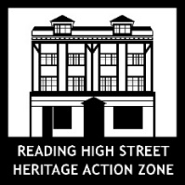
Community Call Out Expression of Interest Form
Group or organisation name:
Contact name:
Contact email address:
Contact number:

- What’s your idea?

2. Who in your group and if applicable the wider community will your project engage?

3. Do you have an artist of creative practitioner or arts organisation that you would like to work with – Yes/No

If you yes – please give their name, art form and web page address and state if they are based in Reading or not.

I give Reading Borough Council permission to contact me by phone Yes/No, by email Yes/No

Signature:
Print name:
Date:

Deadline date for submission – 5pm on Monday 18th July 2022
Please send completed forms to HSHAZ@reading.gov.uk

