**Reading High Street Heritage Action Zone Community Representative**

The Reading High Street Heritage Action Zone (HSHAZ) Community Representatives are local people who attend certain HSHAZ meetings and groups to represent their communities. This role description has been written to clarify the role of the HSHAZ Community Representative and to provide information on how we can support you in your role.

**We need High Street Heritage Action Zone Community Representatives**

The High Street Heritage Action Zone programme, a four-year programme funded by Historic England. Reading was selected as one of 68 areas in England to receive a share of the fund. As a result, Reading Borough Council has been awarded £806,500 to transform the high streets in three conservation areas in the town centre; the East end of Oxford Road, St Mary’s Butts & Castle Street and Market Place & London Street.

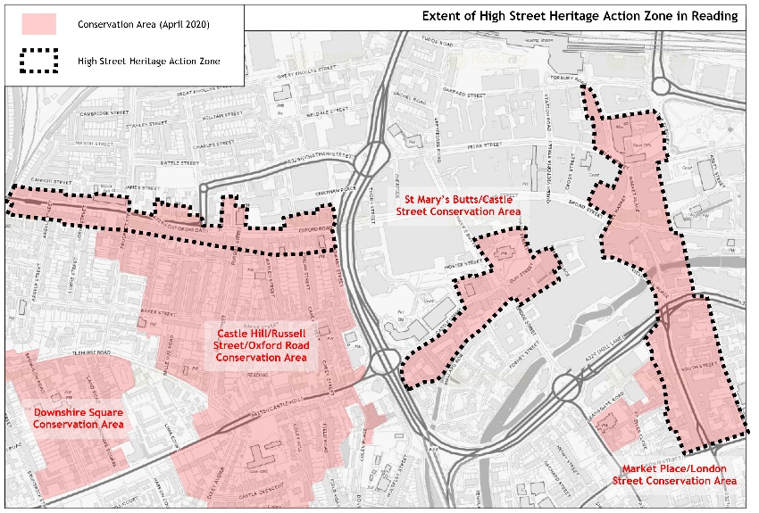

The HSHAZ programme has three complementary strands; **physical interventions** to restore and repair building and improve the public realm, a **programme of cultural activities** to celebrate the high streets and their importance to local communities, and **community engagement** which give local people a key role in deciding what work they want to see happening on their high streets.

We are looking for two community representatives who can help us with the Cultural Programme.

More information about the project is available at [www.reading.gov.uk/hshaz](http://www.reading.gov.uk/hshaz)

**The Role**

The role will include the following:

* To represent and advocate for the interests of your community (geographic or interest)
* Act as a communication point between the HSHAZ project and the group/community you represent sharing information both ways
* To attend HSHAZ Cultural Consortium meetings and take part in the discussion and debate at the meetings (up to 10 meetings until the end of the project in March 2024)
* To bring your expertise or local knowledge to discussions and decision making within the HSHAZ project
* Be part of the HSHAZ Cultural Programme Selection Panel for the applications to the HSHAZ Cultural Programme Oxford Road Projects (up to 6 meetings between December 2021 and March 2022)
* To help promote and champion the HSHAZ cultural programme activities and opportunities (at points between May 2022 and March 2024)
* To encourage and support local people to take part in the HSHAZ cultural programme activities and opportunities (at points between May 2022 and March 2024)
* Assist in putting us in touch with appropriate contacts within the community to promote HSHAZ cultural programme activities and opportunities (at points between May 2022 and March 2024)
* Talk with local residents to identify opinions and feedback on the HSHAZ project (at points between May 2022 and March 2024)

**The role will suit you if you are:**

* Able to commit to being a HSHAZ Community Reprsentative until March 2024 when the project will end
* Interested in local history, heritage and arts
* Enjoy meeting new people
* Interested in helping to give the community a voice
* Able to attend meetings and confident to take part in discussions
* Confident in approaching and engaging with people
* Sympathetic, polite and an interested listener
* Able to work both independently and as part of a team
* Able to feedback information to members of your group and community including learning and explaining clearly project information, aims and objectives
* Passionate about Reading and it’s communities

\***We are particularly interested in recruiting community representatives who live in or work with the communities in the three HSHAZ zones we are working in.**

**What you will gain in return:**

* Introduction session where you will learn about the HSHAZ project
* Ongoing support from the HSHAZ Community Engagement and Cultural Officer
* Become part of a friendly team
* Learn more about the history, heritage and communities of Reading
* Contribute to the development of the HSHAZ project
* Gain new skills and experiences for your CV

**Who does the role report to?** Community Engagement & Cultural Officer – [Hannah.dix@reading.gov.uk](mailto:Hannah.dix@reading.gov.uk)

**How do I become a HSHAZ Community Representative?**

Completed the HSHAZ Community Representative Form below and return it to the HSHAZ Community Engagement and Cultural Officer at [HSHAZ@reading.gov.uk](mailto:HSHAZ@reading.gov.uk) by **5pm Friday 17th December.**

**Reading’s High Street Heritage Action Zone (HSHAZ) Community Representative**

Name:

Address:

Contact number:

Contact email address:

What community group/organisation do you belong to?

What is your role within this group/organisation?

Please tell us a little about yourself, why you are interested in becoming a HSHAZ Community Representative and what you will bring to the role:

Pl

Please return your completed form to [HSHAZ@reading.gov.uk](mailto:HSHAZ@reading.gov.uk) by **5pm** **Friday 17th December 2021**