Ellen Kent and the Ukrainian Opera & Ballet Theatre Kyiv
PUCCINI’S LA BOHÈME
with international soloists, highly-praised chorus and full orchestra

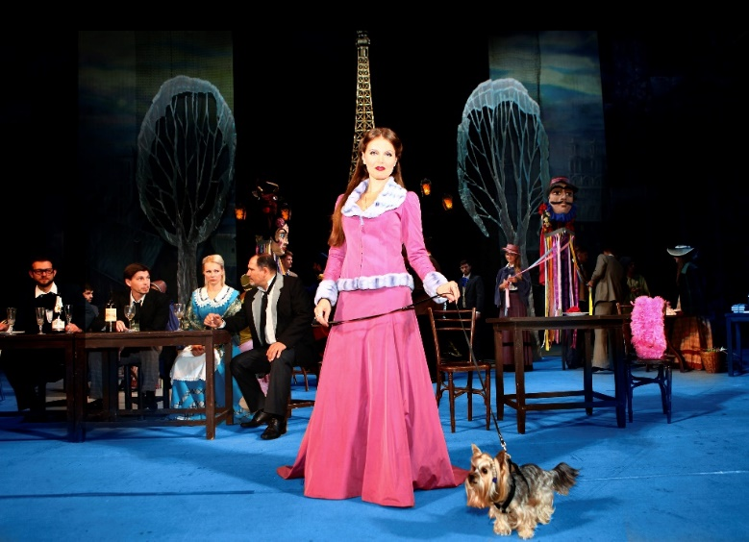

THE HEXAGON – Thurs 13 April ’23, 7.30pm
https://whatsonreading.com/venues/hexagon/whats-on/la-boheme
Box Office 0118 960 6060
whatsonreading.com

DOES YOUR DOG HAVE WHAT IT TAKES TO BE AN OPERA STAR?
Has your dog got star quality? If your pet pooch is the canine equivalent of Brad Pitt or Scarlett Johansson, then they could win a place in the spotlight in the beautiful and romantic opera La Bohème, coming to the Hexagon Theatre on Thurs 13 April 2023.

Award-winning opera director and producer Ellen Kent said: “People say never work with children or animals, but I love to do both. The first time was 20 years ago when my pet cat Holly Go-Lightly was in one of my productions and was an instant hit. Since then we’ve had horses, dogs, goldfish and even a golden eagle with a 6ft wingspan on stage.

“Many years ago, when we last did La Bohème and asked local people to volunteer their pets it was a huge success. We even used a rescue dog once and found him dozens of new owners! We’re a nation of animal lovers after all. I’m sure there is plenty of doggie talent out there.”

Your pet needs to be well behaved, small, used to people and quiet – and as his owner, you will need to be prepared to go on-stage in costume to look after him or her.

TO AUDITION YOUR DOG, send a photograph to Angela Klappa her email is angela@ellenkent.co.uk Please include your contact number and address as well as the breed, height, weight, age, and name of your dog.
Deadline for entries is Friday 24 March 2023.
The successful dog (owner) will be contacted a week before the performance.
Ellen Kent brings one of the most romantic operas ever written to the stage in her new tour, traditionally staged featuring beautiful sets and costumes. The set reflects the Bohemian art of the period and will include a brass band, snow effects and a full choir and orchestra. Performed in the traditional Italian with English surtitles.

Puccini’s masterpiece, La Bohème, is based on Henri Murger’s novel Scenes de la vie de boheme. Set in Paris, it focuses on the tragic love between seamstress Mimi and penniless poet Rodolfo.

This Ellen Kent Production is presented by Senbla by arrangement with Opera International.

Tickets for La Boheme are available from www.whatsonreading.com
For more information contact: ellen@senbla.com / angela@ellenkent.co.uk

